## horizontal line

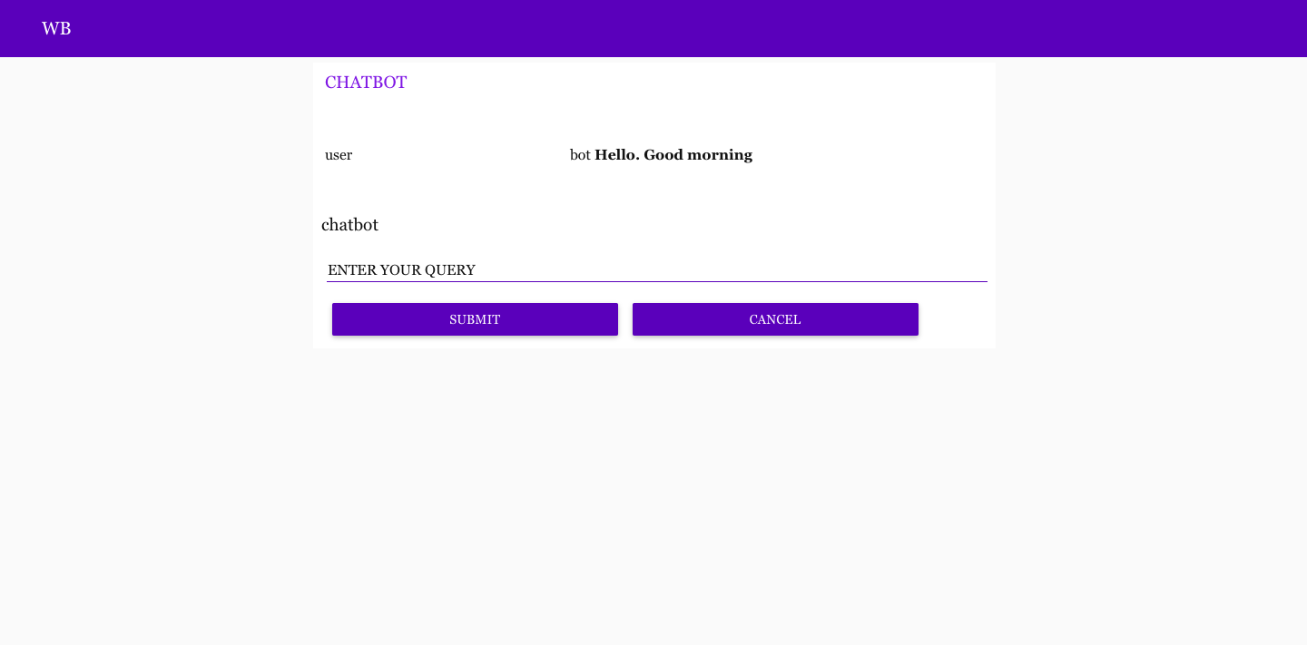

Intelligent Customer Help Desk With Smart Document Understanding

Your Name

Hrishita Singh

[hs4134@srmist.edu.in](mailto:hs4134@srmist.edu.in)

Artificial intelligence

# 1.Overview

We will be able to write an application that leverages multiple Watson AI

Services (Discovery , Assistant, Cloud function and Node Red). By the end of the project, we’ll learn best practices of combining Watson services, and how they can build interactive information retrieval systems with Discovery + Assistant.

* ProjectRequirements:Python,IBMCloud,IBMWatson
* FunctionalRequirements:IBM cloud
* TechnicalRequirements:AI ,ML, WATSON AI, PYTHON
* SoftwareRequirements:Watson assistant, Watson discovery.
* ProjectDeliverables:Smart internz Internship
* ProjectTeam:Hrishita Singh
* ProjectDuration:30 days

**1.2 Purpose:**

The typical customer care chatbot can answer simple questions, such as store locations and hours, directions, and maybe even making appointments. When a question falls outside of the scope of the predetermined question set, the option is typically to tell the customer the question isn’t valid or offer to speak to a real person. In this project, there will be another option. If the customer question is about the operation of a device, the application shall pass the question onto Watson Discovery Service, which has been pre-loaded with the device’s owner’s manual. So now, instead of “Would you like to speak to a customer representative?” we can return relevant sections of the owner’s manual to help solve our customers’ problems. To take it a step further, the project shall use the Smart Document Understanding feature of Watson Discovery to train it on

what text in the owner’s manual is important and what is not. This will improve the answers returned from the queries.

**1.2.1 Scope of Work:**

* ● Create a customer care dialog skill in Watson Assistant
* ● Use Smart Document Understanding to build an enhanced Watson  
  Discovery collection
* ● Create an IBM Cloud Functions web action that allows Watson  
  Assistant to post queries to Watson Discovery
* ● Build a web application with integration to all these services & deploy  
  the same on IBM Cloud Platform

**2.LITERATURE SURVEY  
2.1 Existing problem:** Generally Chatbots means getting input from users and getting only response questions and for some questions the output from bot will be like “try again”, “I don’t understand”, “will you repeat again”, and so on... and directs customer to customer agent but a good customer Chatbot should minimize involvement of customer agent to chat with customer to clarify his/her doubts. So to achieve this we should include an virtual agent in chatbot so that it will take care of real involvement of customer agent and customer can clarifies his doubts with fast chatbots.

**2.2 Proposed solution:** For the above problem to get solved we have to put an virtual agent in chatbot so it can understand the queries that are posted by customers. The virtual agent should trained from some insight records based company background so it can answer queries based on the product or related to company. In this project I used Watson Discovery to achieve the above solution. And later including Assistant and Discovery on Node-RED

**3.THEORITICAL ANALYSIS**

**3.1 Block/Flow Diagram:**

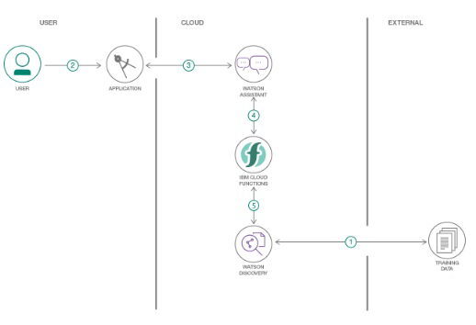

1.The document is annotated using Watson Discovery SDU

2. The user interacts with the backend server via the app UI. The frontend app UI is a chatbot that engages the user in a conversation.

3. Dialog between the user and backend server is coordinated using a Watson Assistant dialog skill.

4. If the user asks a product operation question, a search query is passed to a predefined IBM Cloud Functions action.

5. The Cloud Functions action will query the Watson Discovery service and return the results.

**3.2 Hardware / Software designing**:

1. Create IBM Cloud services

2. Configure Watson Discovery

3. Create IBM Cloud Functions action 4. Configure Watson Assistant

5. Create flow and configure node 6. Deploy and run Node Red app.

**4.EXPERIMENTAL INVESTIGATIONS 1.Create IBM Cloud services**

Create the following services:

* ● Watson Discovery
* ● Watson Assistant
* ● Node Red
* ● IBM cloud function  
  **Creation of Node-RED in IBM cloud:**
* ● Step-1: Login to IBM and go to the catalog
* ● Step-2: Search for node-red and select “Node-RED Starter “ Service
* ● Step-3: Enter the Unique name and click on create a button
* ● Note: Your Node-red service is starting
* ● Step – 5: We have to configure Node red for the first time. Click on next to  
  Continue
* 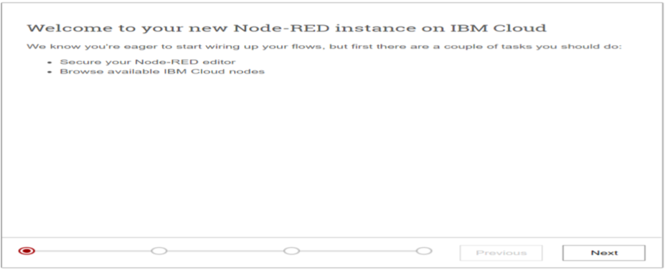

**●** Step – 6: Secure your node red editor by giving a username and password and click on Next

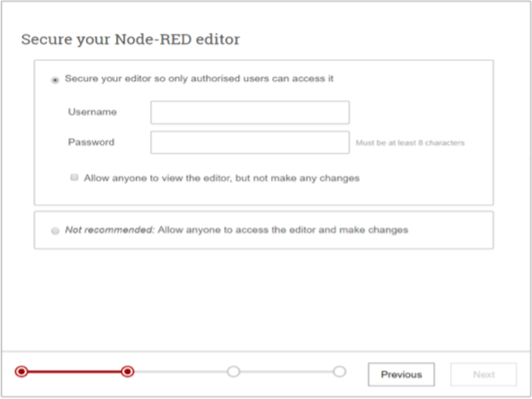

● Step – 7: Click Next to continue

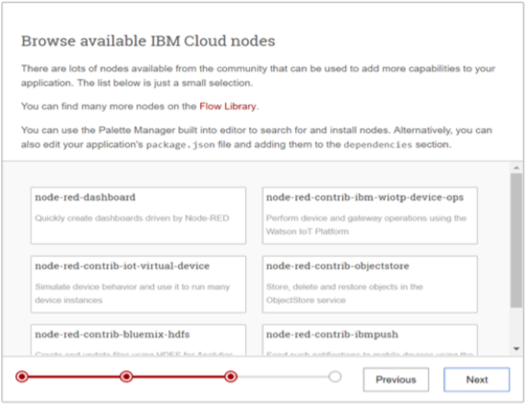

● Step – 8: Click Finish

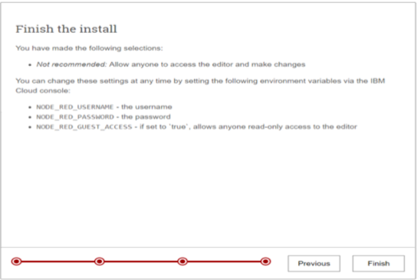

● Step – 9: Click on Go to Node-Red flow editor to launch the flow editor

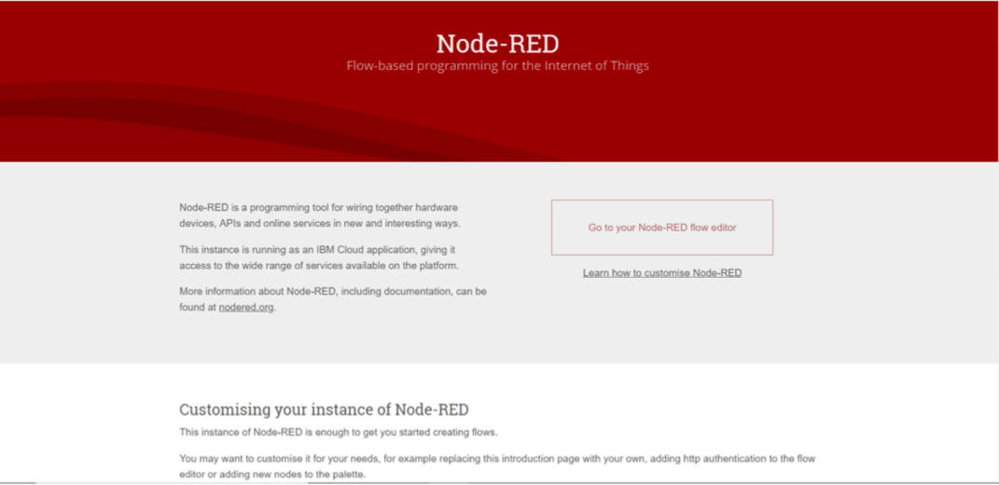

5.FLOWCHART

At first go to manage pallete and install dashboard. Now,Create the flow with the help of following node:

Inject

Assistant Debug

Function Ui_Form Ui_Text

**Creation of Watson discovery instance in IBM Cloud:**

● Import the document

As shown below, launch the Watson Discovery tool and create a new data collection by selecting the Upload your own data option. Give the data collection a unique name. When prompted, select and upload the *ecobee3_UserGuide.pdf.*

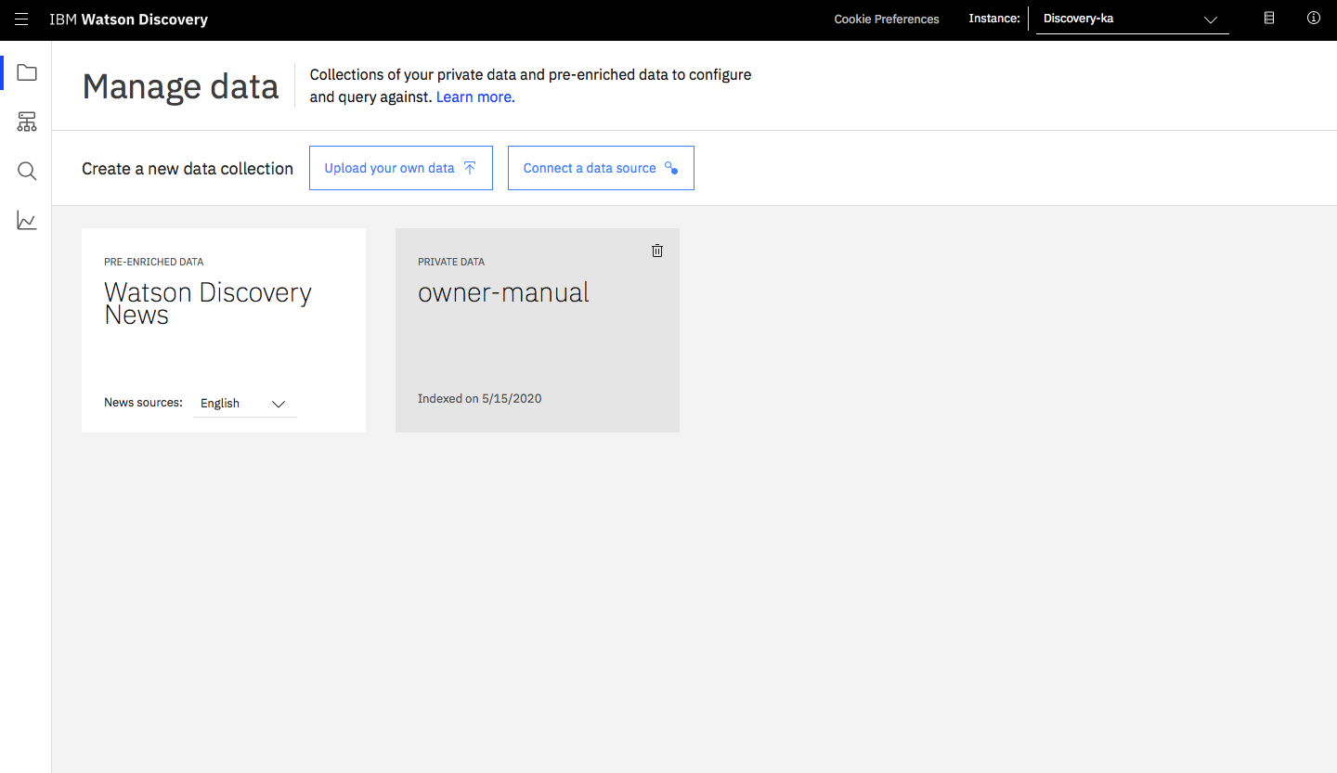

The Ecobee is a popular residential thermostat that has a wifi interface and multiple configuration options.

Before applying SDU to our document, lets do some simple queries on the data so that we can compare it to results found after applying SDU.

**●** Click build your own query button

Enter queries related to the operation of the thermostat and view the results. As you will see, the results are not very useful, and in some cases, not even related to the question. **Annotate with SDU**

Now let's apply SDU to our document to see if we can generate some better query responses.

From the Discovery collection panel, click the Configure data button (located in the top right corner) to start the SDU process.

Here is the layout of the Identify fields tab of the SDU annotation panel:

The goal is to annotate all of the pages in the document so Discovery can learn what text is important, and what text can be ignored.

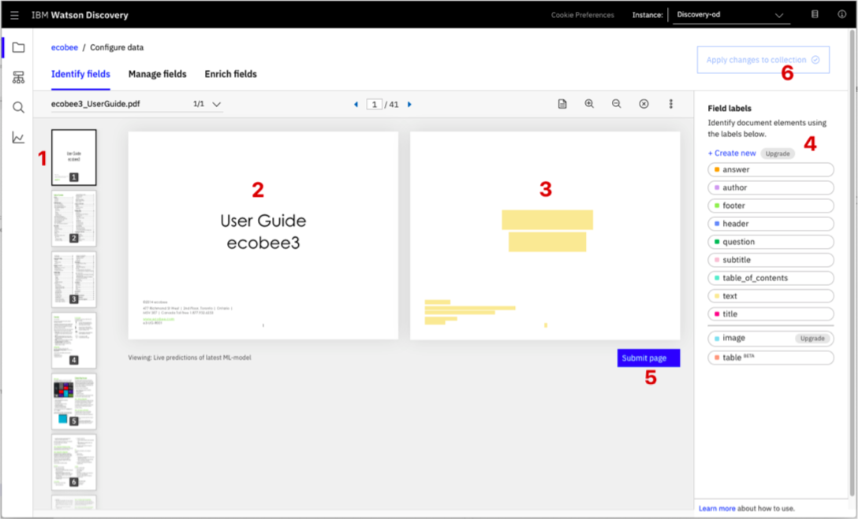

* ● [1] is the list of pages in the manual. As each is processed, a green check mark will appear on the page.
* ● [2] is the current page being annotated.
* ● [3] is where you select text and assign it a label.
* ● [4] is the list of labels you can assign to the page text.
* ● Click [5] to submit the page to Discovery.
* ● Click [6] when you have completed the annotation process.
* As you go though the annotations one page at a time, Discovery is learning and should start automatically updating the upcoming pages. Once you get to a page that is already correctly annotated, you can stop, or simply click Submit [5] to acknowledge it is correct. The more pages you annotate, the better the model will be trained.  
  For this specific owner's manual, at a minimum, it is suggested to mark the following:

● The main title page as title

* ● The table of contents (shown in the first few pages) as table_of_contents
* ● All headers and sub-headers (typed in light green text) as a subtitle
* ● All page numbers as footers
* ● All warranty and licensing infomation (located in the last few pages) as a footer
* ● All other text should be marked as text.
* Once you click the Apply changes to collection button [6], you will be asked to reload the document. Choose the same owner's manual .pdf document as before.
* 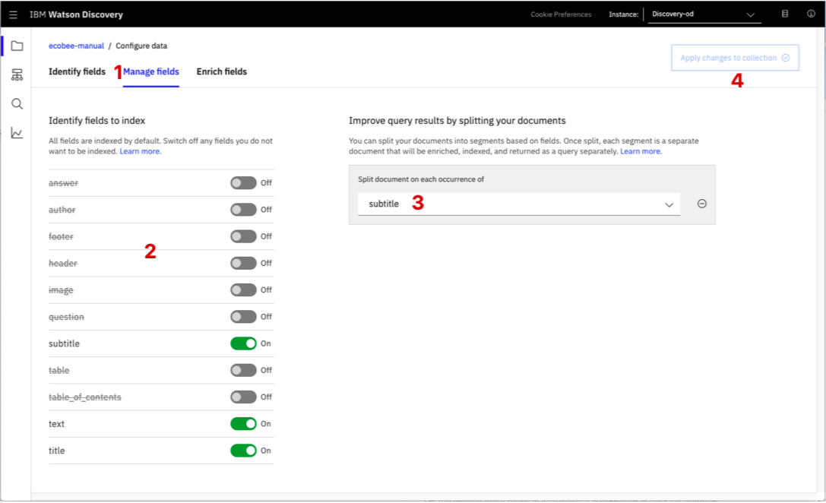  
  Next, click on the Manage fields [1] tab.
* ● [2] Here is where you tell Discovery which fields to ignore. Using the on/off buttons, turn off all labels except subtitles and text.
* ● [3] is telling Discovery to split the document apart, based on subtitle.
* ● Click [4] to submit your changes.

Once again, you will be asked to reload the document.

Now, as a result of splitting the document apart, your collection will look very different:

Return to the query panel (click Build your own query) and see how much better the results are.

Store credentials for future use

In upcoming steps, you will need to provide the credentials to access your Discovery collection. The values can be found in the following locations.

The Collection ID and Environment ID values can be found by clicking the dropdown button [1] located at the top right side of your collection panel:

For credentials, return to the main panel of your Discovery service, and click the Service credentials [1] tab:

Click the View credentials [2] drop-down menu to view the IAM apikey [3] and URL

endpoint [4] for your service.

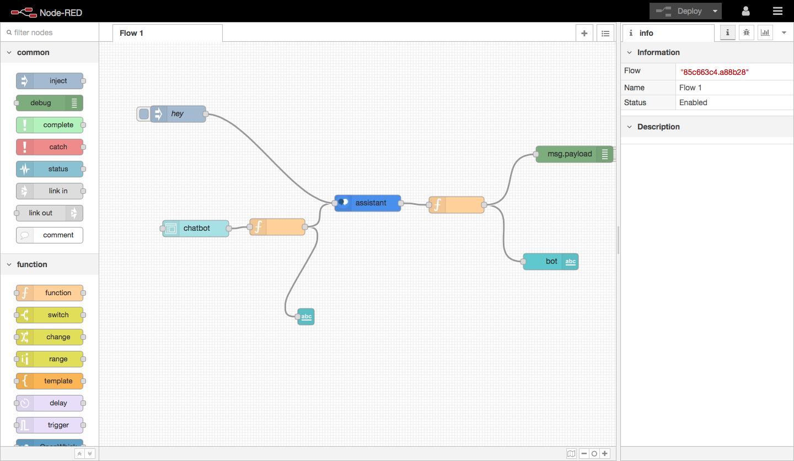

**Creating IBM cloud functions:**

Now let's create the web action that will make queries against our Discovery collection. Start the IBM Cloud Functions service by selecting Create Resource from the IBM Cloud dashboard. Enter functions as the filter [1], then select the Functions card [2]:

From the Functions main panel, click on the Actions tab. Then click on Create.

From the Create panel, select the Create Action option.

On the Create Action panel, provide a unique Action Name [1], keep the default package [2], and select the Node.js 10 [3] runtime. Click the Create button [4] to create the action.

Once your action is created, click on the Code tab [1]:

In the code editor window [2], cut and paste in the code from the disco-action.js file found in the actions directory of your local repo. The code is pretty straight-forward - it simply connects to the Discovery service, makes a query against the collection, then returns the response.

If you press the Invoke button [3], it will fail due to credentials not being defined yet. We'll do this next.

Select the Parameters tab [1]:

Add the following keys: ● url

● environment_id ● collection_id

● iam_apikey

For values, please use the values associated with the Discovery service you created in the previous step.

Note: Make sure to enclose your values in double quotes.

Now that the credentials are set, return to the Code panel and press the Invoke button again. Now you should see actual results returned from the Discovery service:

Next, go to the Endpoints panel [1]:

Click the checkbox for Enable as Web Action [2]. This will generate a public endpoint URL [3].

Take note of the URL value [3], as this will be needed by Watson Assistant in a future step.

To verify you have entered the correct Discovery parameters, execute the provied curl command [4]. If it fails, re-check your parameter values.

NOTE: An IBM Cloud Functions service will not show up in your dashboard resource list. To return to your defined Action, you will need to access Cloud Functions by selecting Create Resource from the main dashboard panel (as shown at the beginning of this step).

**Configure Wstaon Assistant:**

As shown below, launch the Watson Assistant tool and create a new dialog skill. Select the Use sample skill option as your starting point.

This dialog skill contains all of the nodes needed to have a typical call center conversation with a user.

**Add new intent**

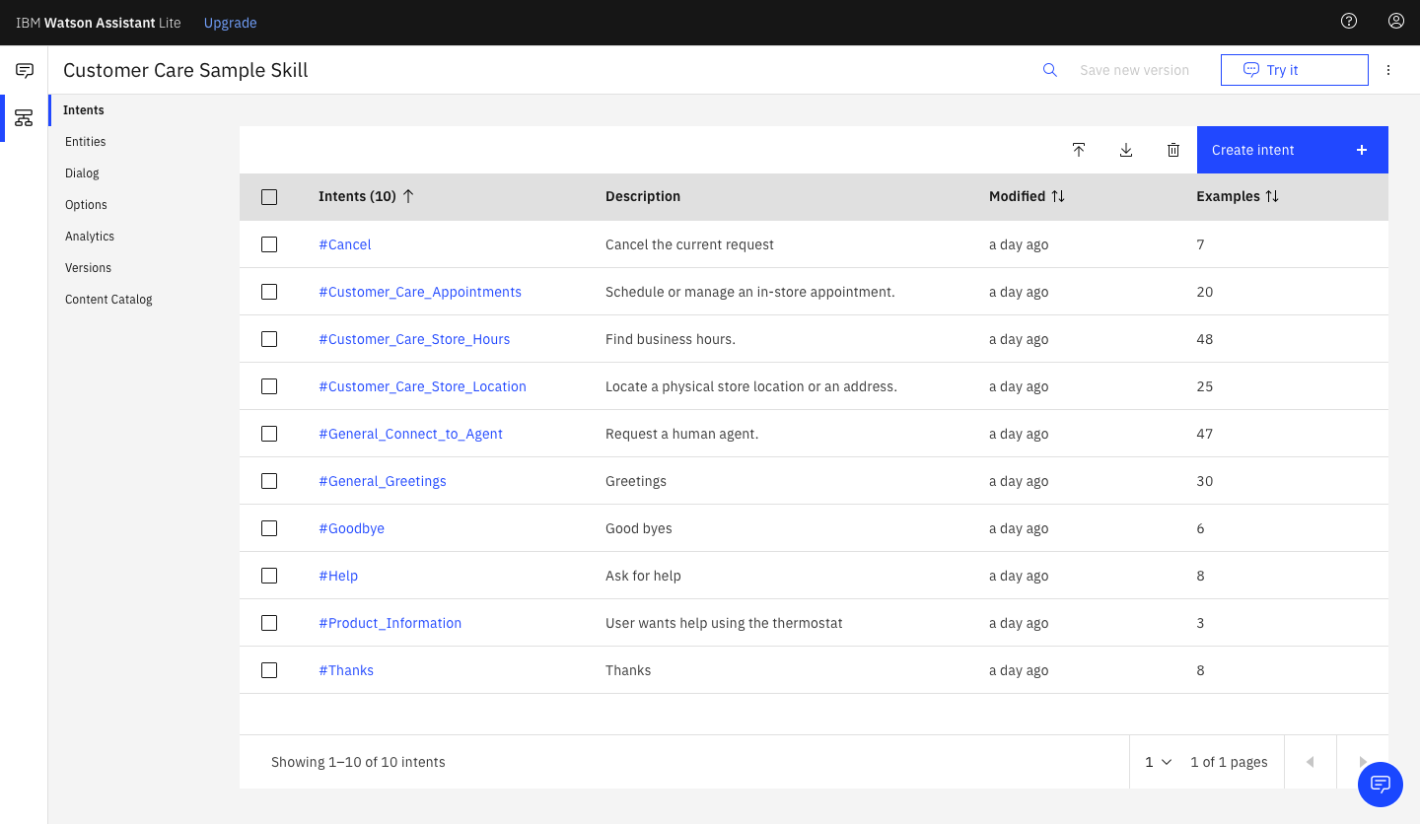

The default customer care dialog does not have a way to deal with any questions involving outside resources, so we will need to add this.

Create a new intent that can detect when the user is asking about operating the Ecobee thermostat.

From the Customer Care Sample Skill panel, select the Intents tab.

Click the Create intent button.

Name the intent #Product_Information, and at a minimum, enter the following example questions to be associated with it.

**Create new dialog node**

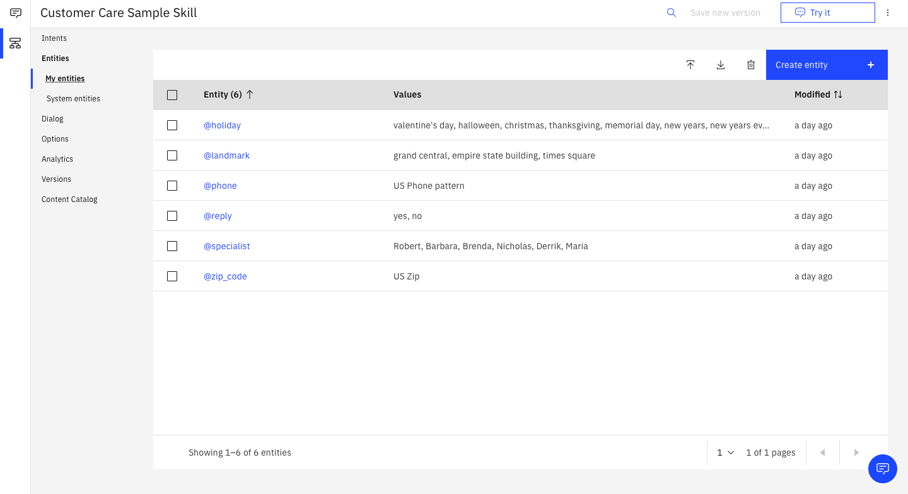

Now we need to add a node to handle our intent. Click on the Dialog [1] tab, then click on the drop down menu for the Small Talk node [2], and select the Add node below [3] option.

Name the node "Ask about product" [1] and assign it our new intent [2].

This means that if Watson Assistant recognizes a user input such as "how do I set the time?", it will direct the conversation to this node.

Enable webhook from Assistant

Set up access to our WebHook for the IBM Cloud Functions action you created in Step #4.

Select the Options tab [1]:

Enter the public URL endpoint for your action [2].

Important: Add .json to the end of the URL to specify the result should be in JSON format.

Return to the Dialog tab, and click on the Ask about product node. From the details panel for the node, click on Customize, and enable Webhooks for this node:

Click Apply.

The dialog node should have a Return variable [1] set automatically to $webhook_result_1. This is the variable name you can use to access the result from the Discovery service query.

You will also need to pass in the users question via the parameter input [2]. The key needs to be set to the value:

"<?input.text?>"

If you fail to do this, Discovery will return results based on a blank query.

Optionally, you can add these responses to aid in debugging:

Add Add “<?webhook_result_1.passages[0].passage_text?>” in respond with in Assistant responds block as shown below.

**Integration of watson assistant in Node-RED**

* ● Double-click on the Watson assistant node
* ● Give a name to your node and enter the username, password and workspace id  
  of your Watson assistant service
* ● After entering all the information click on Done
* ● Drag inject node on to the flow from the Input section
* ● Drag Debug on to the flow from the output section
* ● Double-click on the inject node
* ● Select the payload as a string
* ● Enter a sample input to be sent to the assistant service and click on done
* ● Connect the nodes as shown below and click on Deploy
* ● Open Debug window as shown below
* ● Click on the button to send input text to the assistant node
* ● Observe the output from the assistant service node
* ● The Bot output is located inside “output.text"
* ● Drag the function node to parse the JSON data and get the bot response
* ● Double click on the function node and enter the JSON parsing code as shown  
  below and click on done
* ● Connect the nodes as shown below and click on Deploy

● Re-inject the flow and observe the parsed output

We are done integrating Watson assistant service to Node-red. In the next lab, we will create a web application using Node-red for the chatbot. For creating a web application UI we need “dashboard“ nodes which should be installed manually.

* ● Go to navigation pane and click on manage palette
* ● Click on install
* ● Search for “node-red-dashboard” and click on install and again click on install on  
  the prompt
* ● The following message indicates dashboard nodes are installed, close the  
  manage palette
* ● Search for “Form” node and drag on to the flow
* ● Doube click on the “form” node to configure
* ● Click on the edit button to add the “Group” name and “Tab” name
* ● Click on the edit button to add tab name to web application
* ● Give sample tab name and click on add do the same thing for the group
* ● Give the label as “Enter your input”, Name as “text” and click on Done
* ● Drag a function node, double-click on it and enter the input parsing code as  
  shown below
* ● Click on done
* ● Connect the form output to the input of the function node and output of the  
  function to input of assistant node
* ● Search for “text” node from the “dashboard” section
* ● Drag two “text” nodes on to the flow
* ● Double click on the first text node, change the label as “You” and click on Done
* ● Double click on the second text node, change the label as “Bot” and click on Done
* ● Connect the output of “input parsing” function node to “ You” text node and  
  output of “Parsing” function node to the input of “Bot” text node
* ● Click on Deploy

1.Create flow and configure node:

**6.RESULTS**

Finally our Node-RED dash board integrates all the components and displayed in the Dashboard UI by typing URL-https://node-red-znzdl.eu-gb.mybluemix.net/ui in browser

**Advantages:**

**7.ADVANTAGES & DISADVANTAGES**

* ● Campanies can deploy chatbots to rectifiy simple and general human queries .
* ● Reduces man power
* ● Cost efficient
* **●** No need to divert calls to customer agent and customer agent can look on other  
  works.  
  **Disadvantages:**
* ● Some times chatbot can mislead customers
* ● Giving same answer for different sentiments.
* ● Some times cannot connect to customer sentiments and intentions.

**8.APPLICATIONS**

* ● It can deploy in popular social media applications like facebook,slack,telegram.
* **●** Chatbot can deploy any website to clarify basic doubts of viewers.

**9.CONCLUSION** By doing the above procedure and all we successfully created an Intelligent helpdesk smart chatbot using Watson assistant, Watson discovery, Node-RED and cloud-functions.

**10.FUTURE SCOPE**We can include watson studio text to speech and speech to text services to access the chatbot handsfree. This is one of the future scope of this project.